Lab 2

Course Code – CLCM 3506

Due Date – Mar 29, 2024 11:59 PM

Group 2

Ashutosh Chaudhary (443957)

Taniya Kamboj (441808)

Zeren Ju (452688)

Akilandeshwari Srinivasan (451036)

Ambedkar Rani Subbiah (442771)

**Description:**

Deploying/Hosting a CloudLearnerHub Website on AWS Cloud using Terraform.

**Assumptions:**

* Target Audience: Aspiring cloud professionals, individuals interested in computer science courses, and businesses seeking cloud training for their employees.
* Key Features: Course listings, detailed course descriptions, pricing plans, user registration/login, secure payment processing, contact forms for inquiries, dynamic content updates, version control with Git, and database hosting on Amazon RDS.
* Security Measures: Implement HTTPS for secure communication, implement IAM policies for access control, enable encryption for data at rest and in transit, configure monitoring and logging for AWS services, and conduct regular security audits.
* Technologies: React, Bootstrap for frontend; Node js, Express js for backend; Git for version control; Terraform for infrastructure provisioning; Amazon RDS for database hosting; AWS IAM for access management; VPC setup for network isolation.

**Architectural Diagram:**

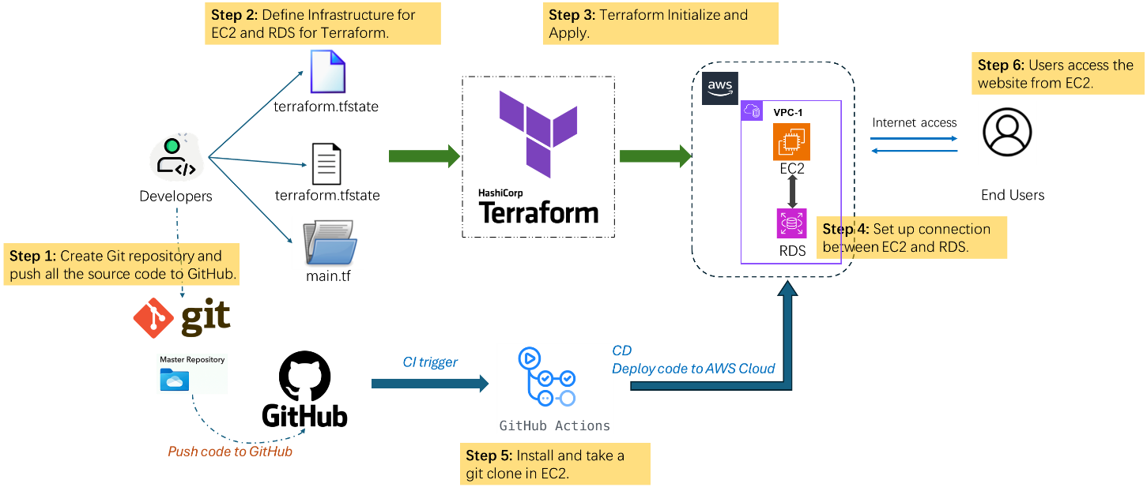

Step 1: Create Git repository and push all the source code to GitHub.

Step 2: Define Infrastructure for EC2 and RDS for Terraform.

Step 3: Terraform Initialize and Apply.

Step 4: Set up connection between EC2 and RDS.

Step 5: Install and take a git clone in EC2.

Step 6: Host the website from EC2.

**Process:**

1. **Website Creation:** The website is developed using various technologies like React, Bootstrap for the frontend and Node js, Express js for Backend. The code is managed using Git, a version control system.
2. **Infrastructure as Code with Terraform:** Terraform is used to define and provision the required infrastructure resources in a cloud environment such as AWS. This includes setting up an EC2 instance for hosting the website and an RDS instance for the backend data. The configuration for these resources is defined in Terraform configuration files.
3. **Setting Inbound Rules:** Inbound rules are configured to allow traffic to reach the EC2 instance and the RDS instance. This typically involves setting up security groups or network ACLs to permit incoming connections on specific ports.
4. **Connecting RDS to EC2:** The EC2 instance needs to be able to communicate with the RDS instance to access the backend data. This involves configuring the database settings in the application code to connect to the RDS instance, as well as ensuring that the security groups or network settings allow traffic between the two.
5. **Deployment Commands:** Once everything is set up, deployment commands are used to push the code to the EC2 instance and start the web server. This involves using SSH to connect to the EC2 instance and then running commands to pull the latest code from the Git repository, install any dependencies, and start the server.

**Screenshots:**

Create EC2 and RDS using Terraform 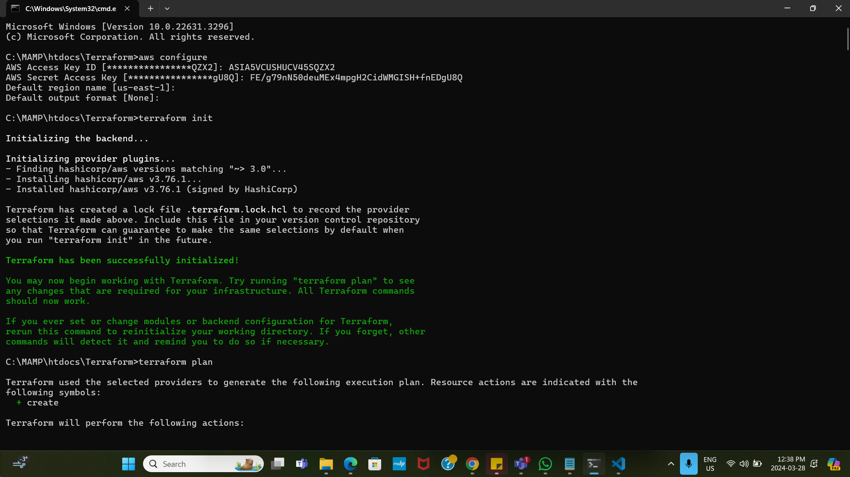

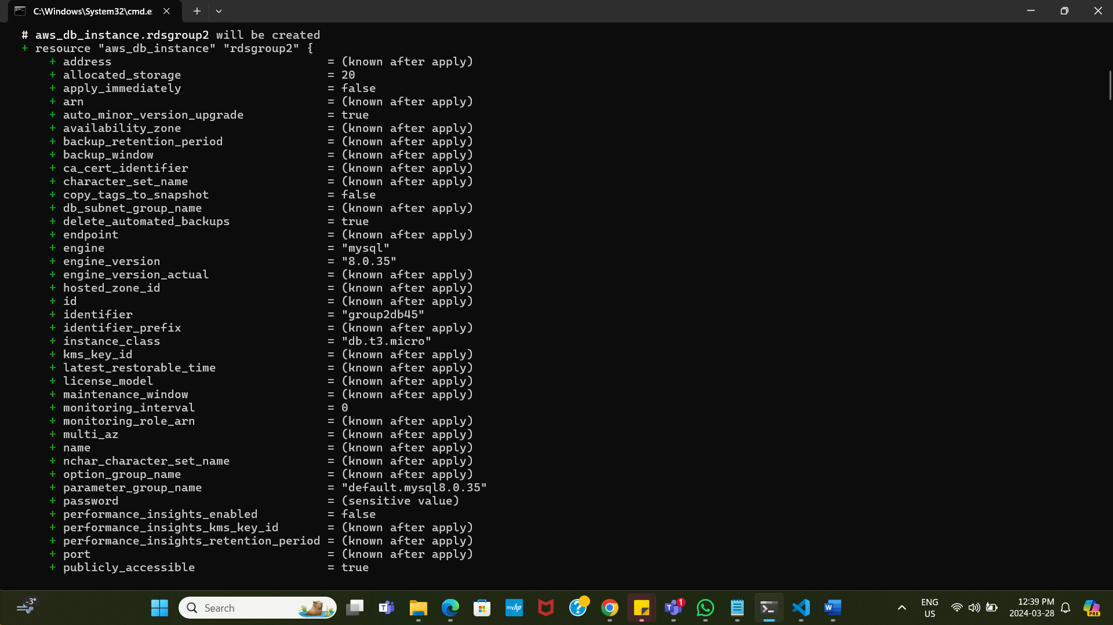

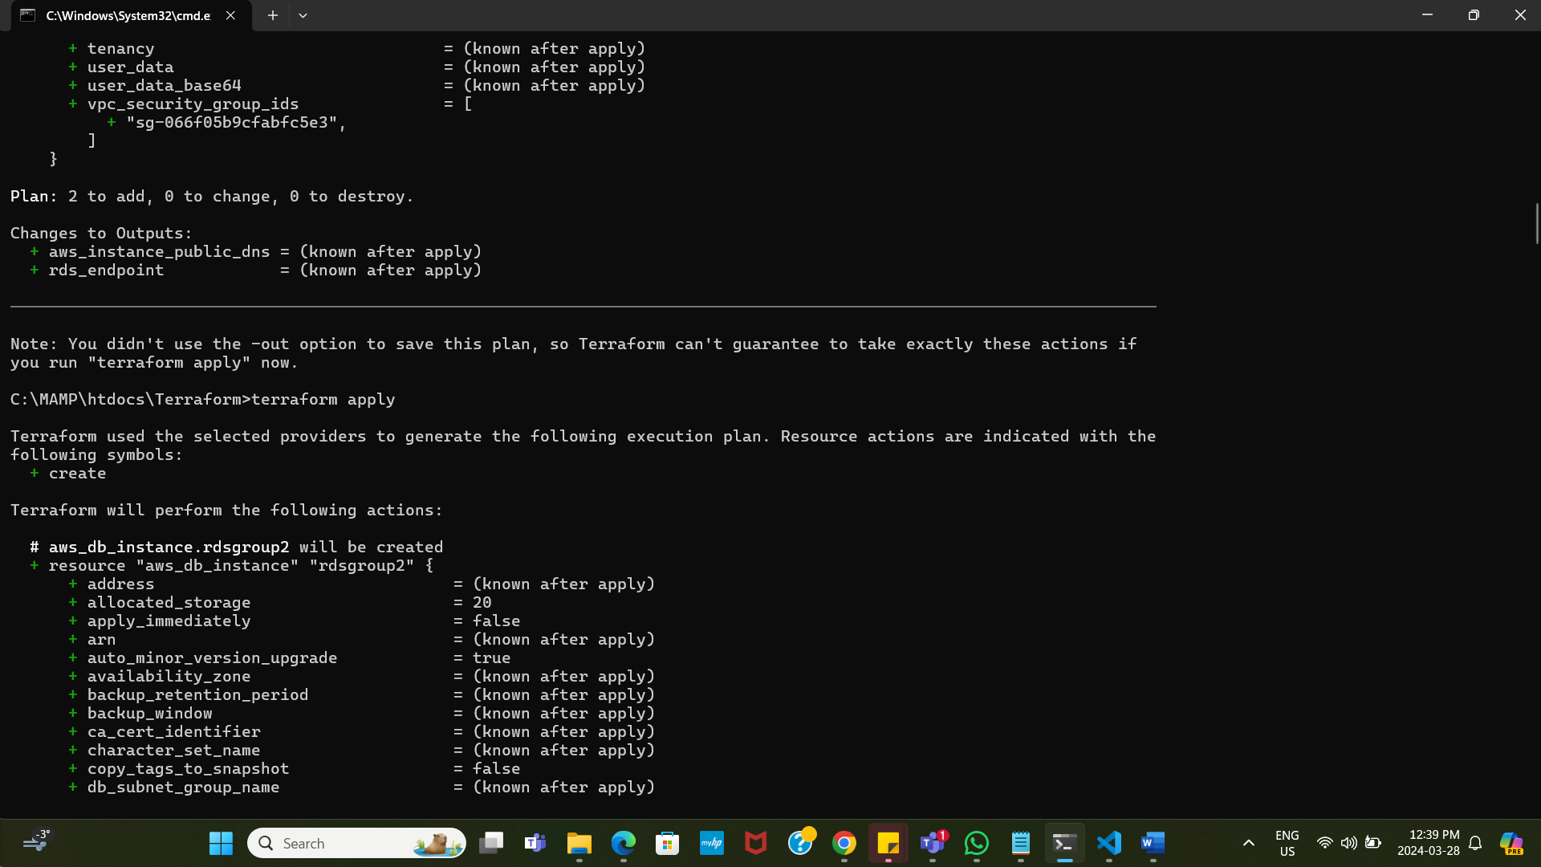



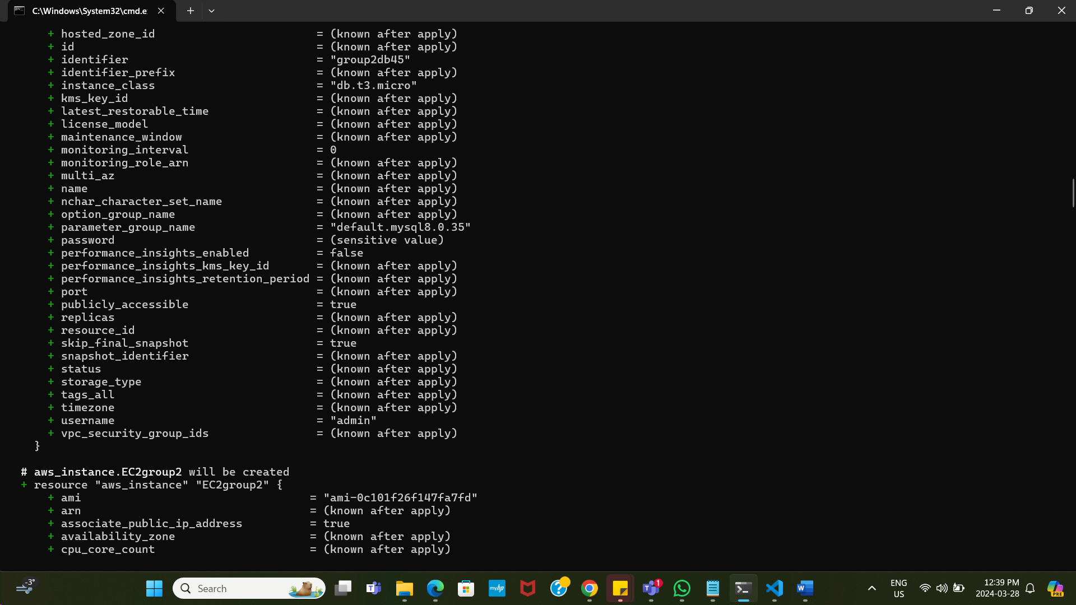

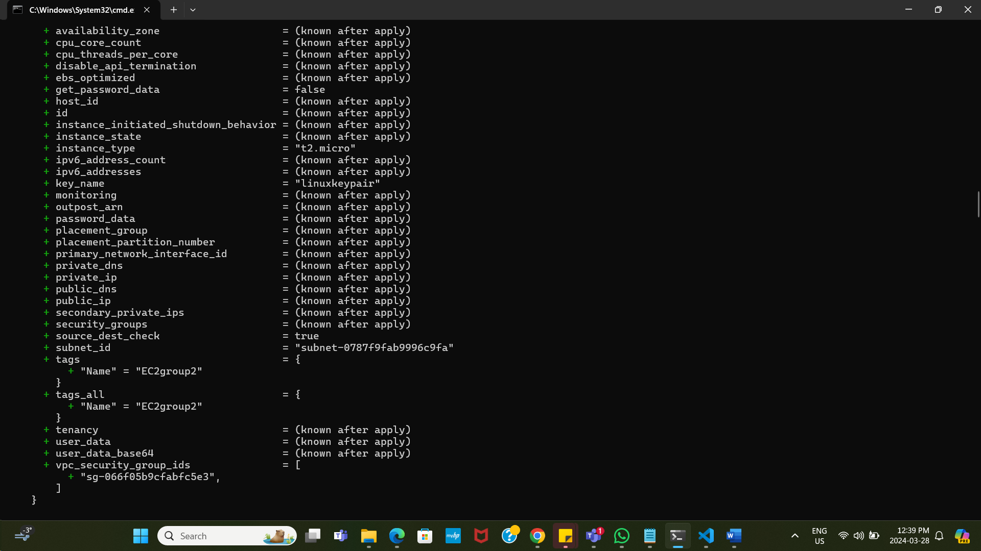

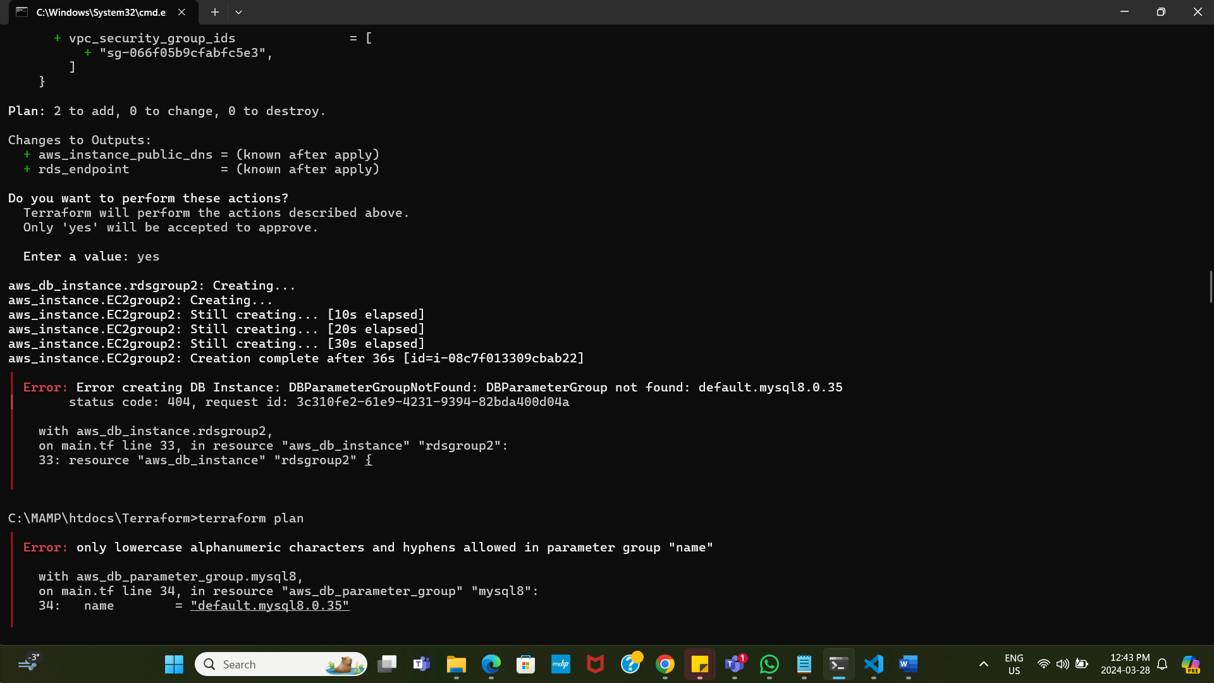

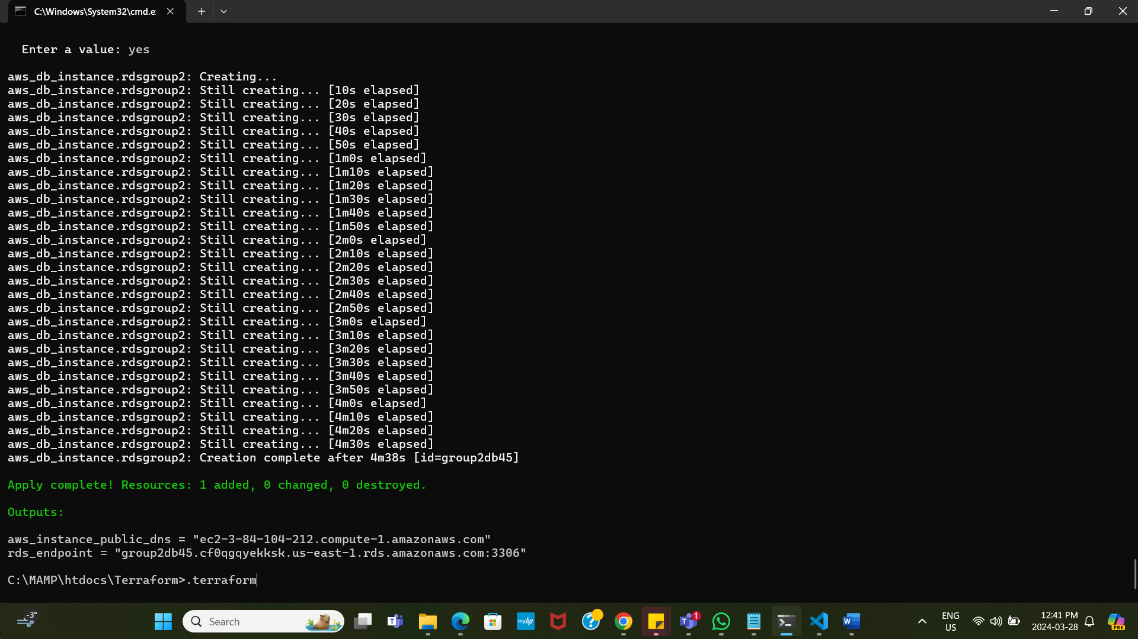

EC2

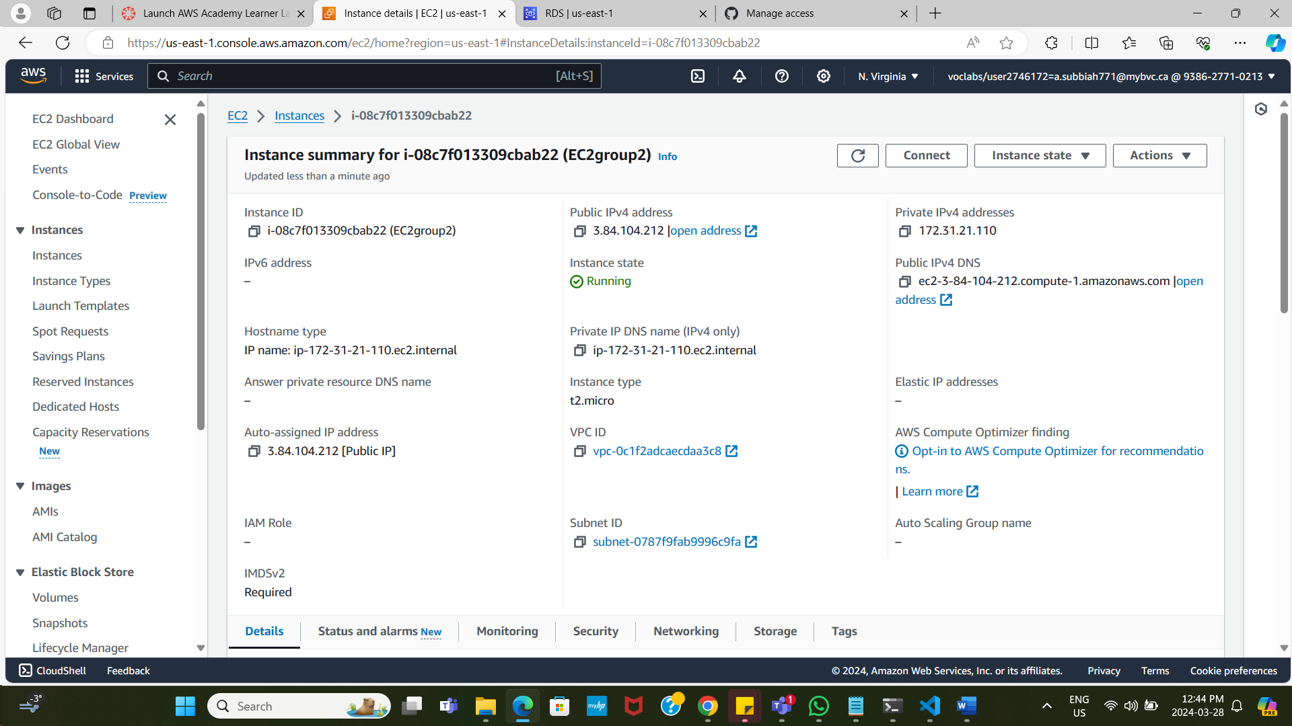

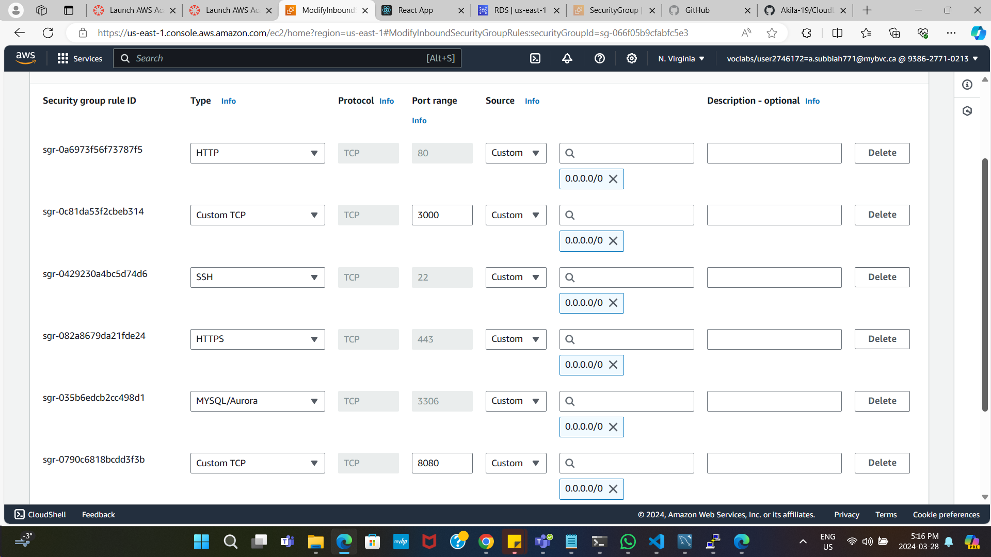

RDS

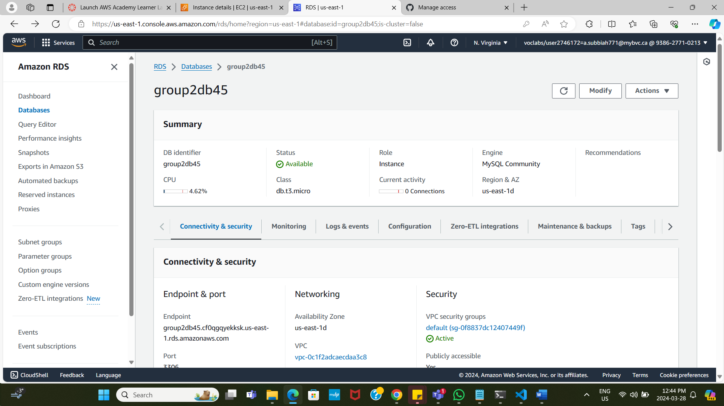

Connect Putty

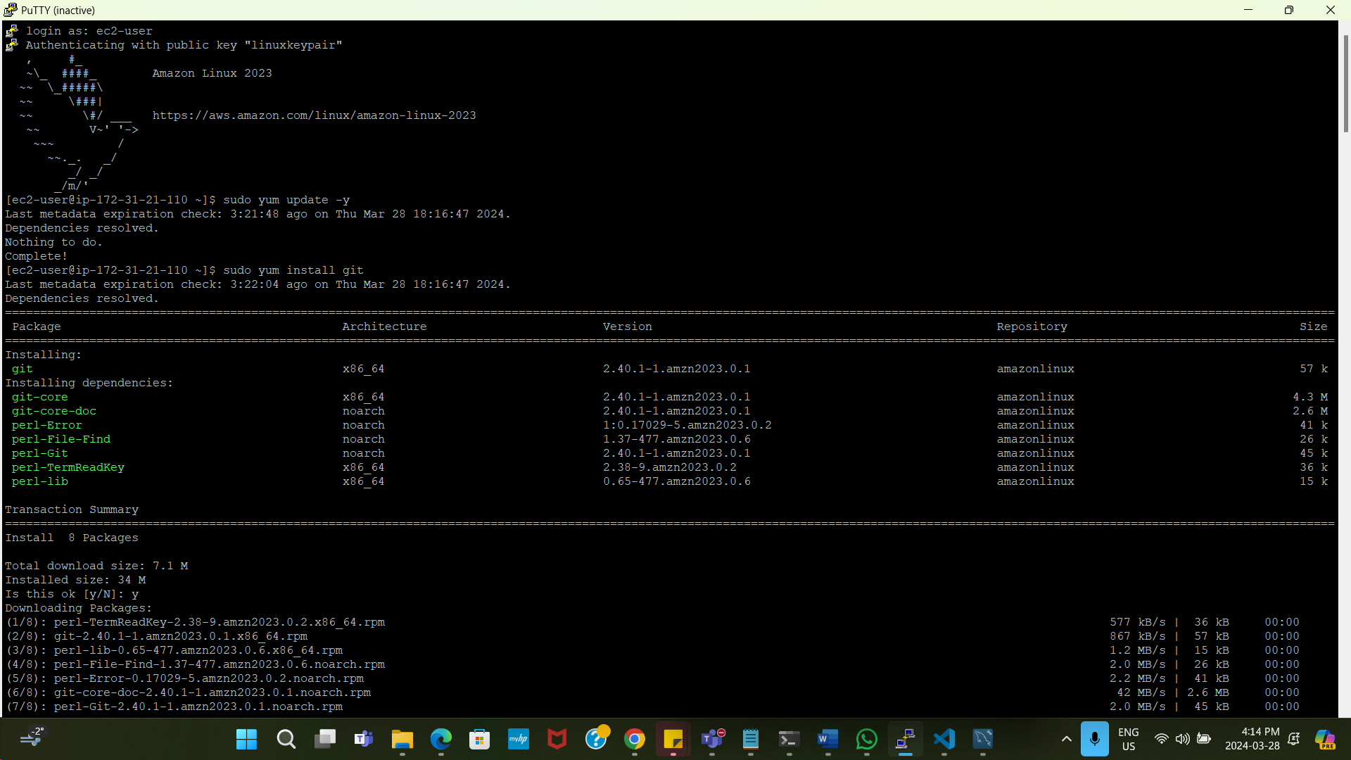

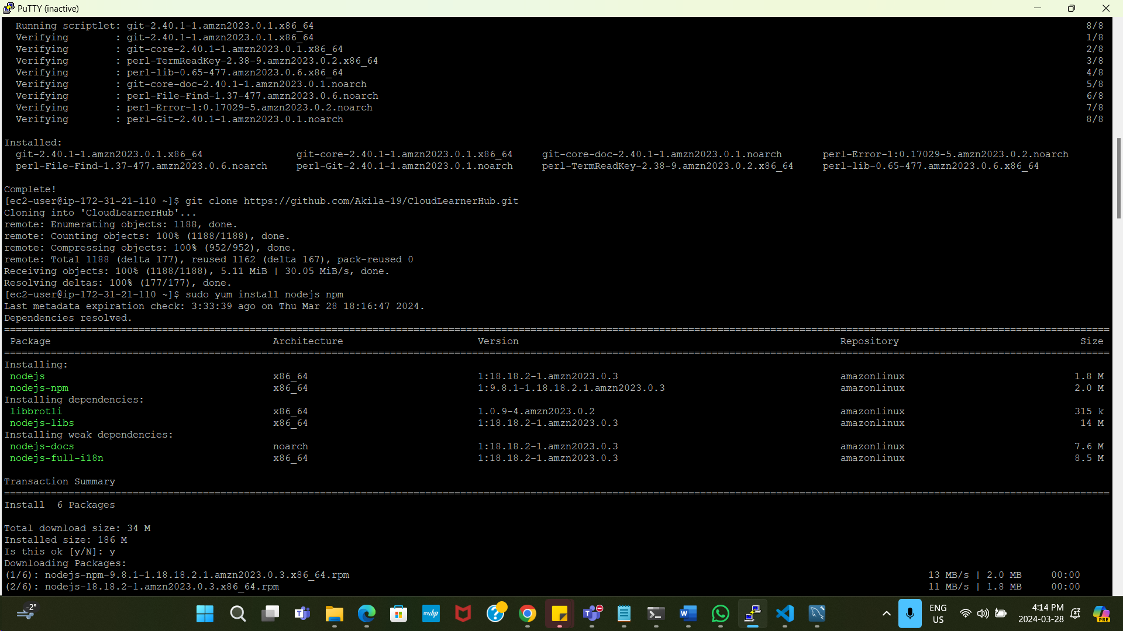

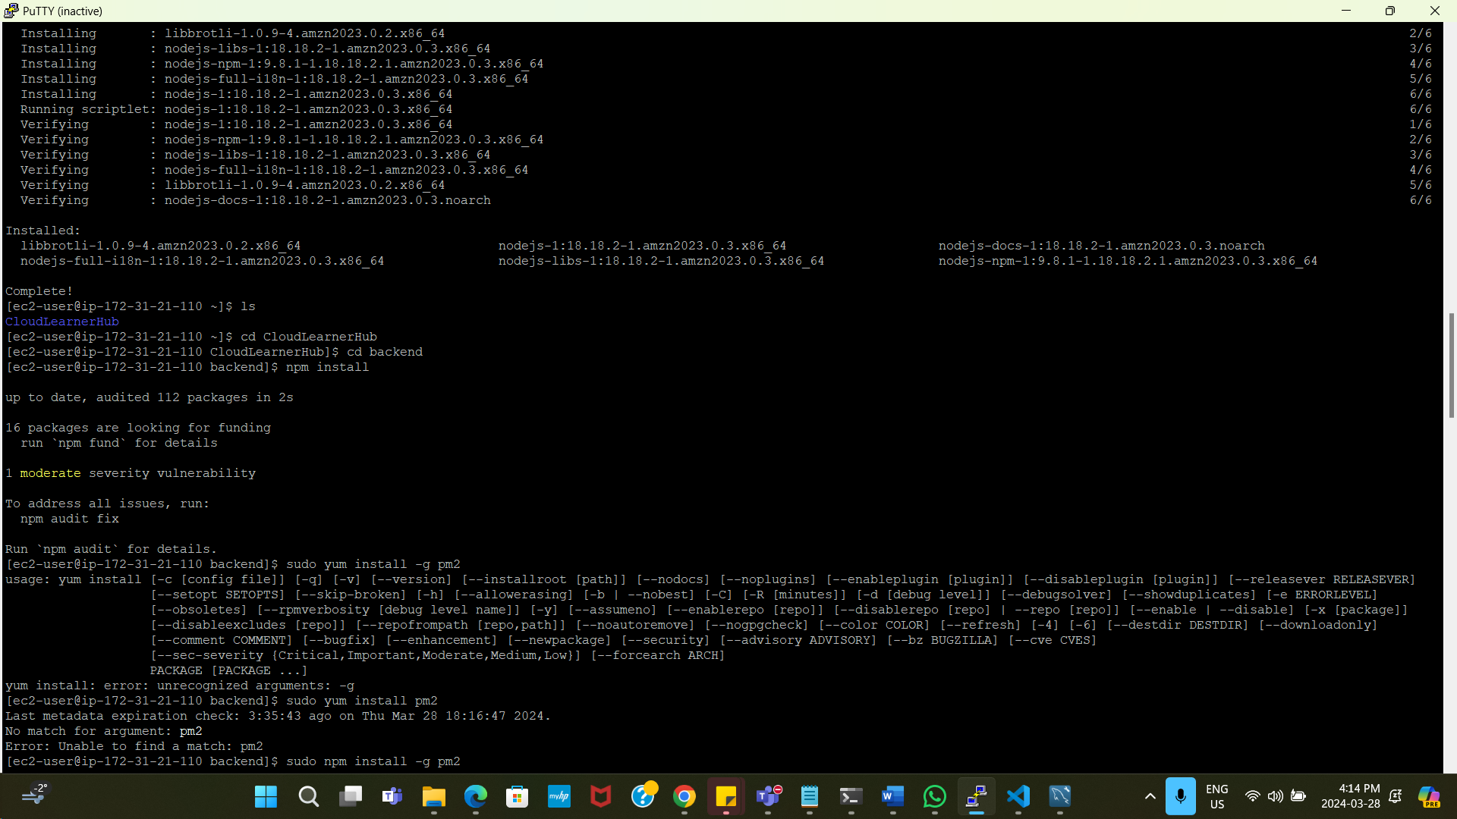

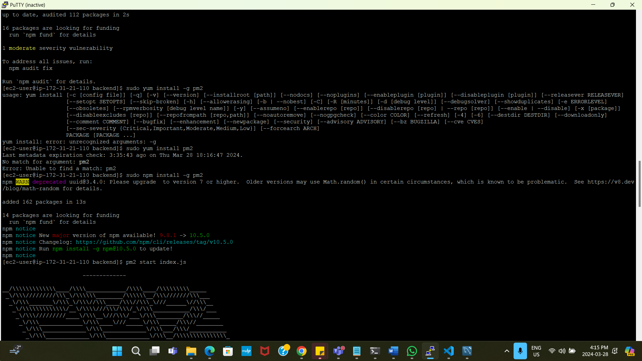

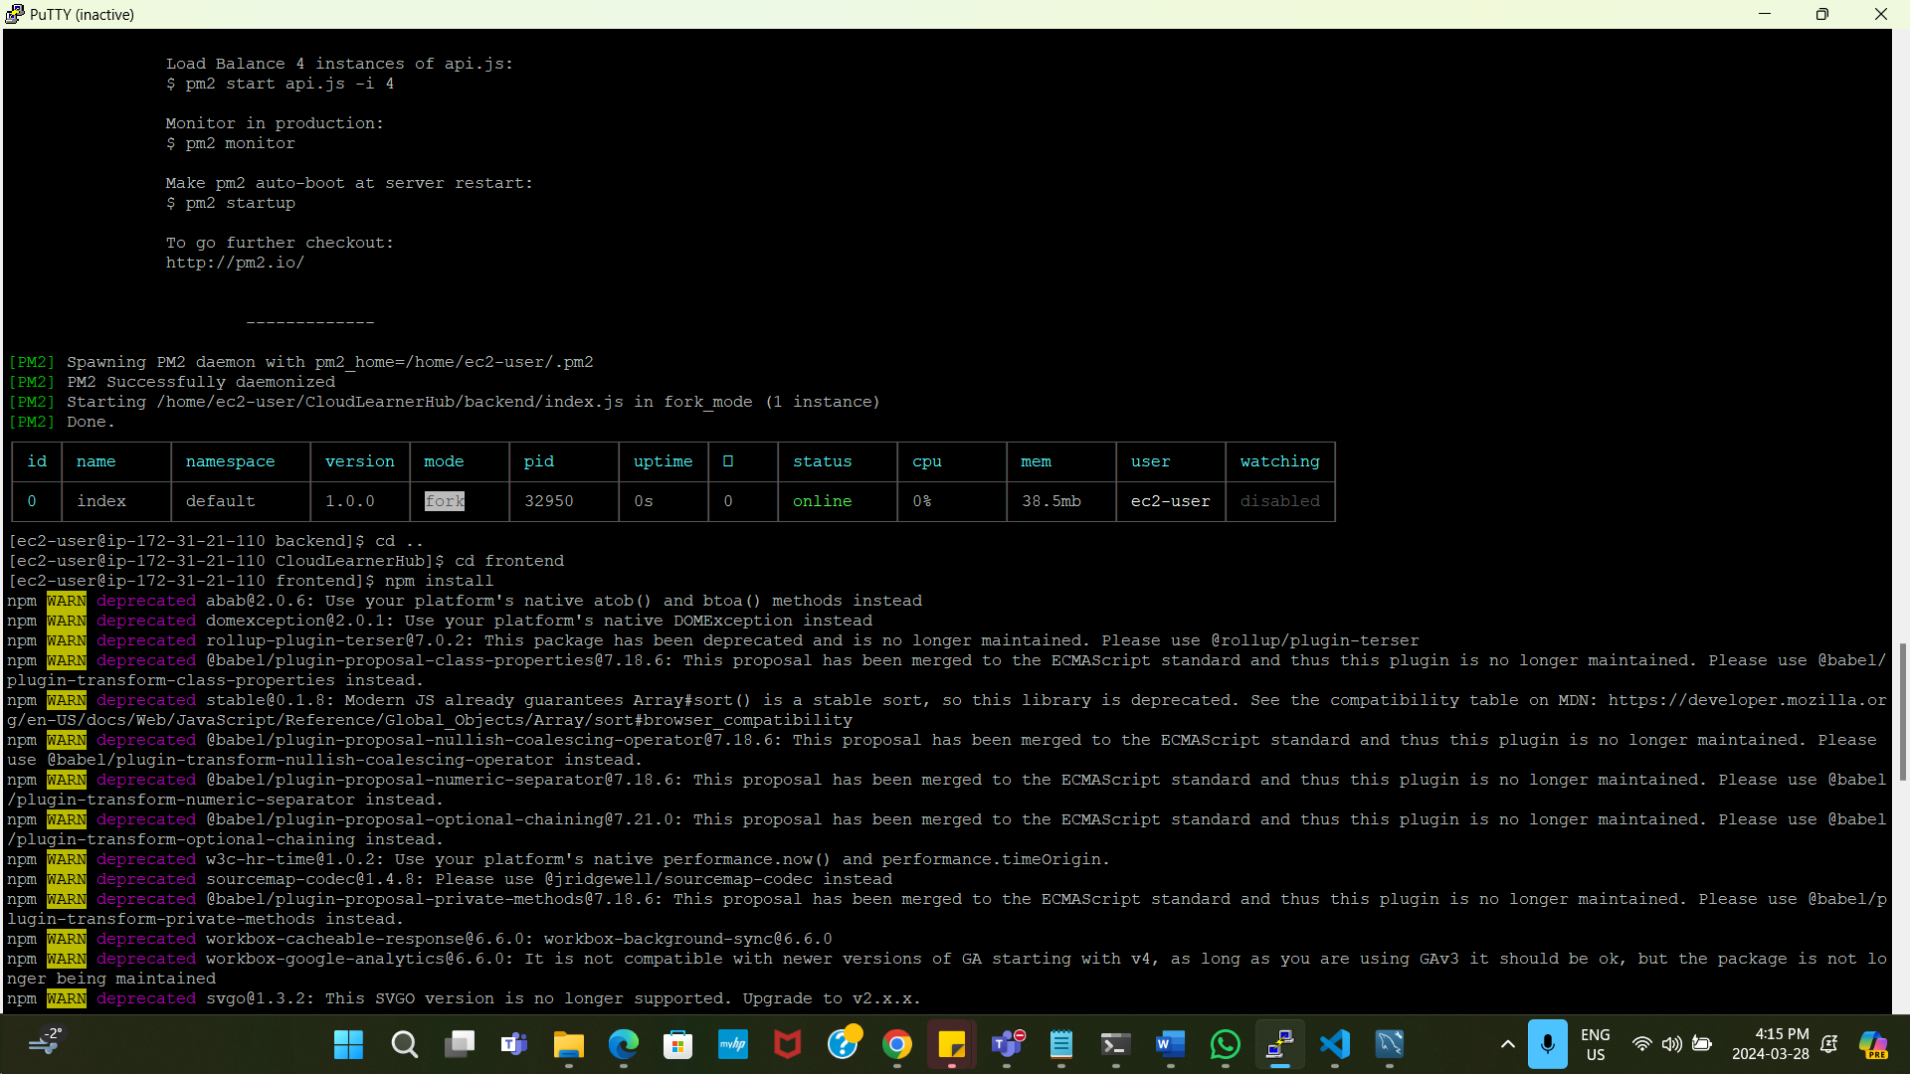

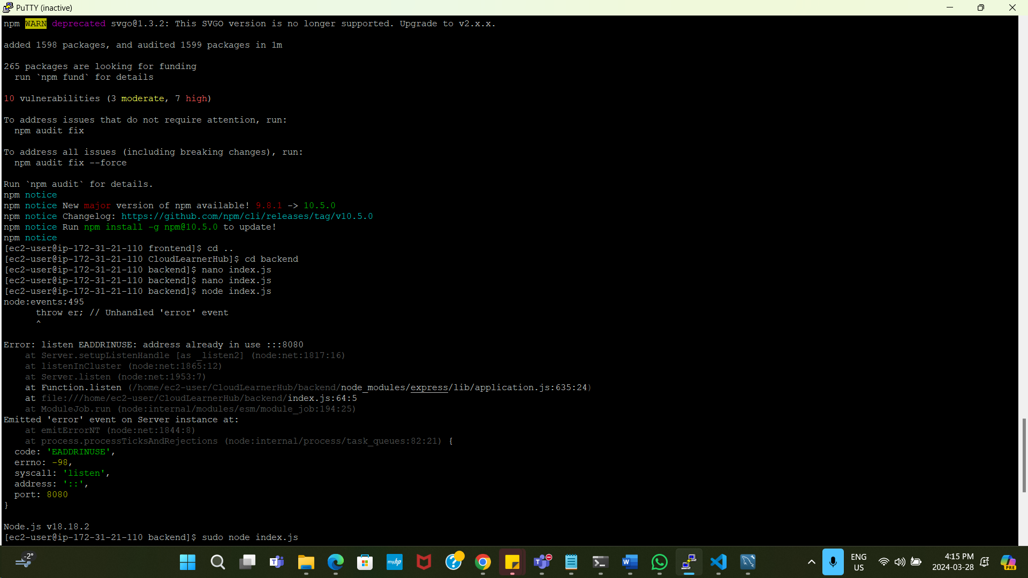

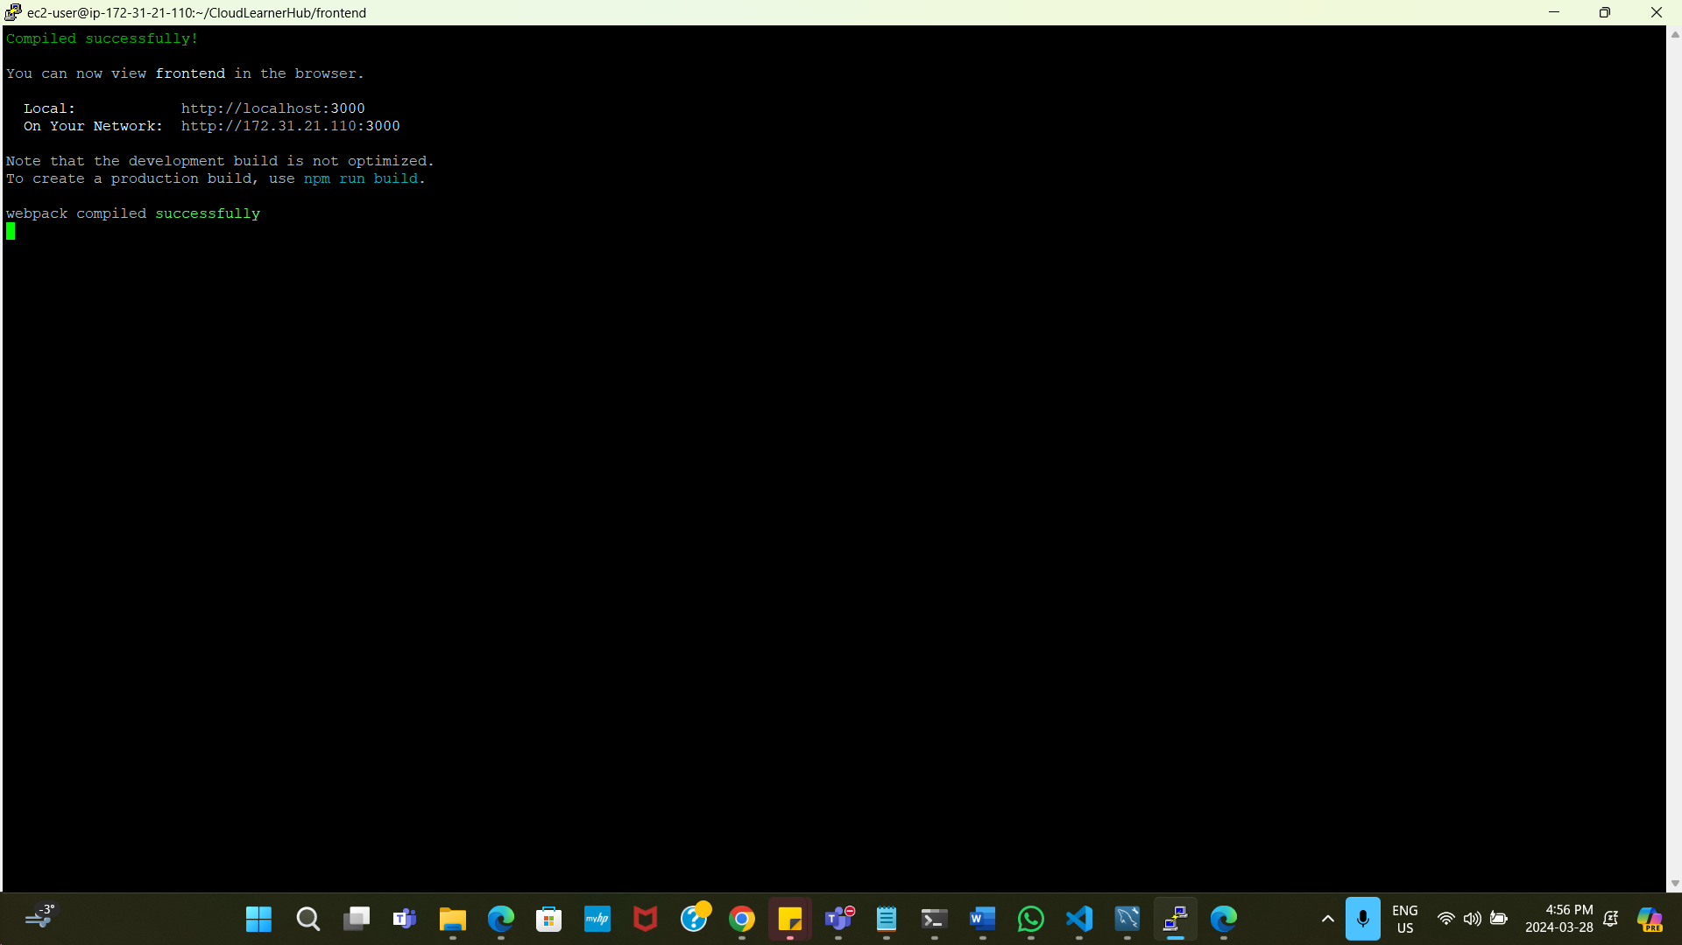

[React App](http://ec2-44-223-62-130.compute-1.amazonaws.com:3000/) : http:// ec2-44-223-62-130.compute-1.amazonaws.com:3000

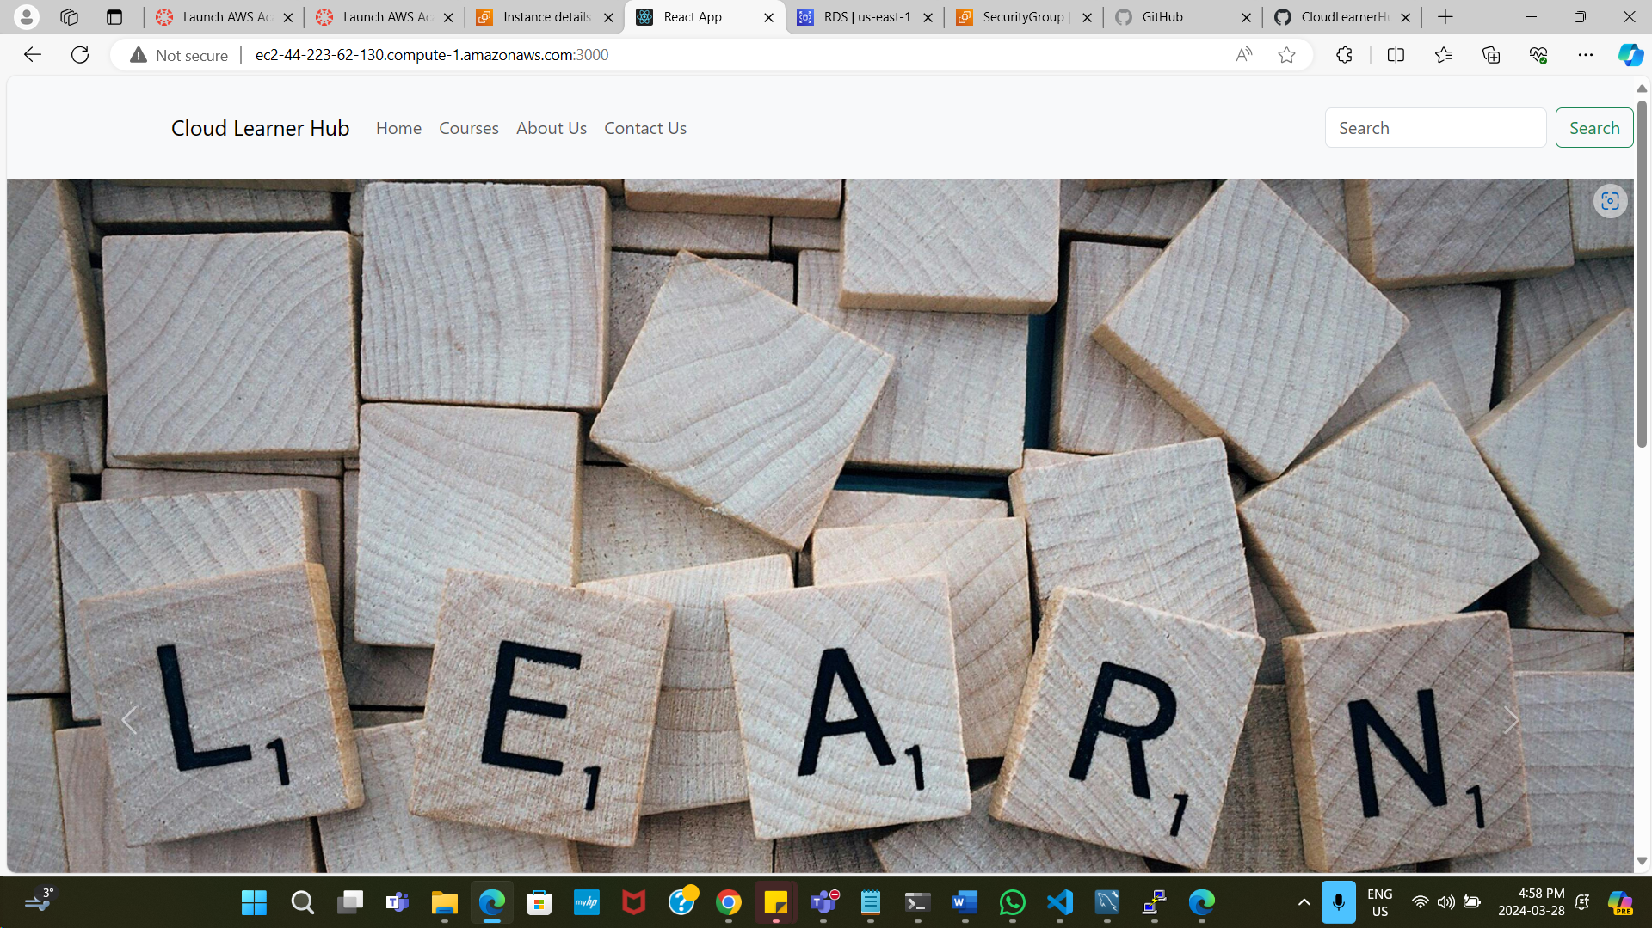

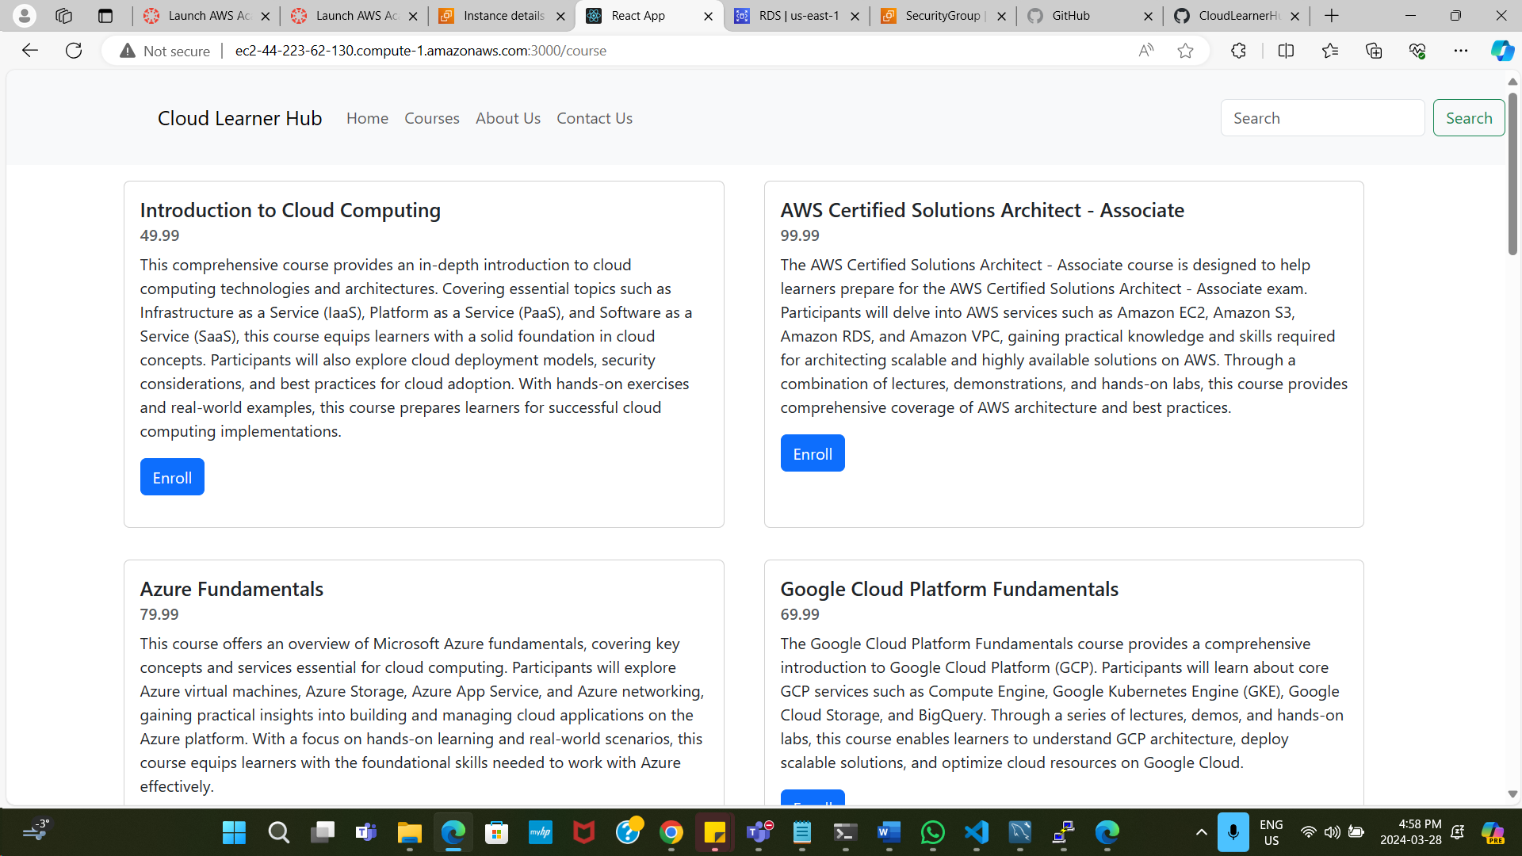

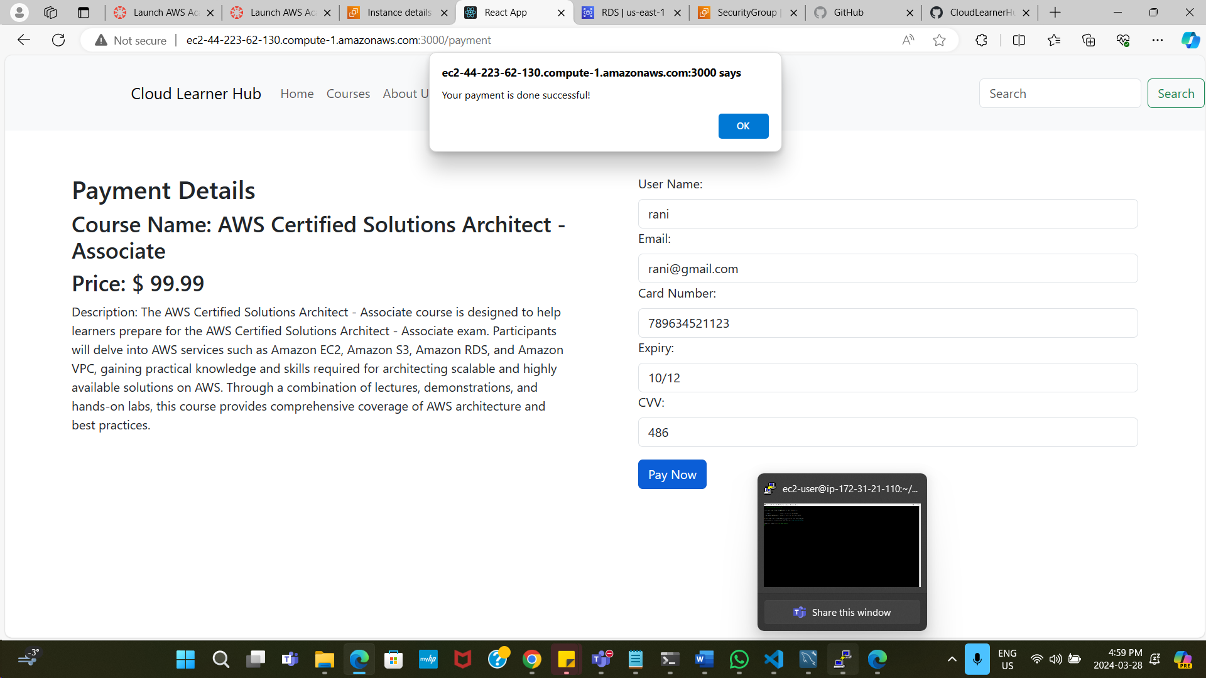

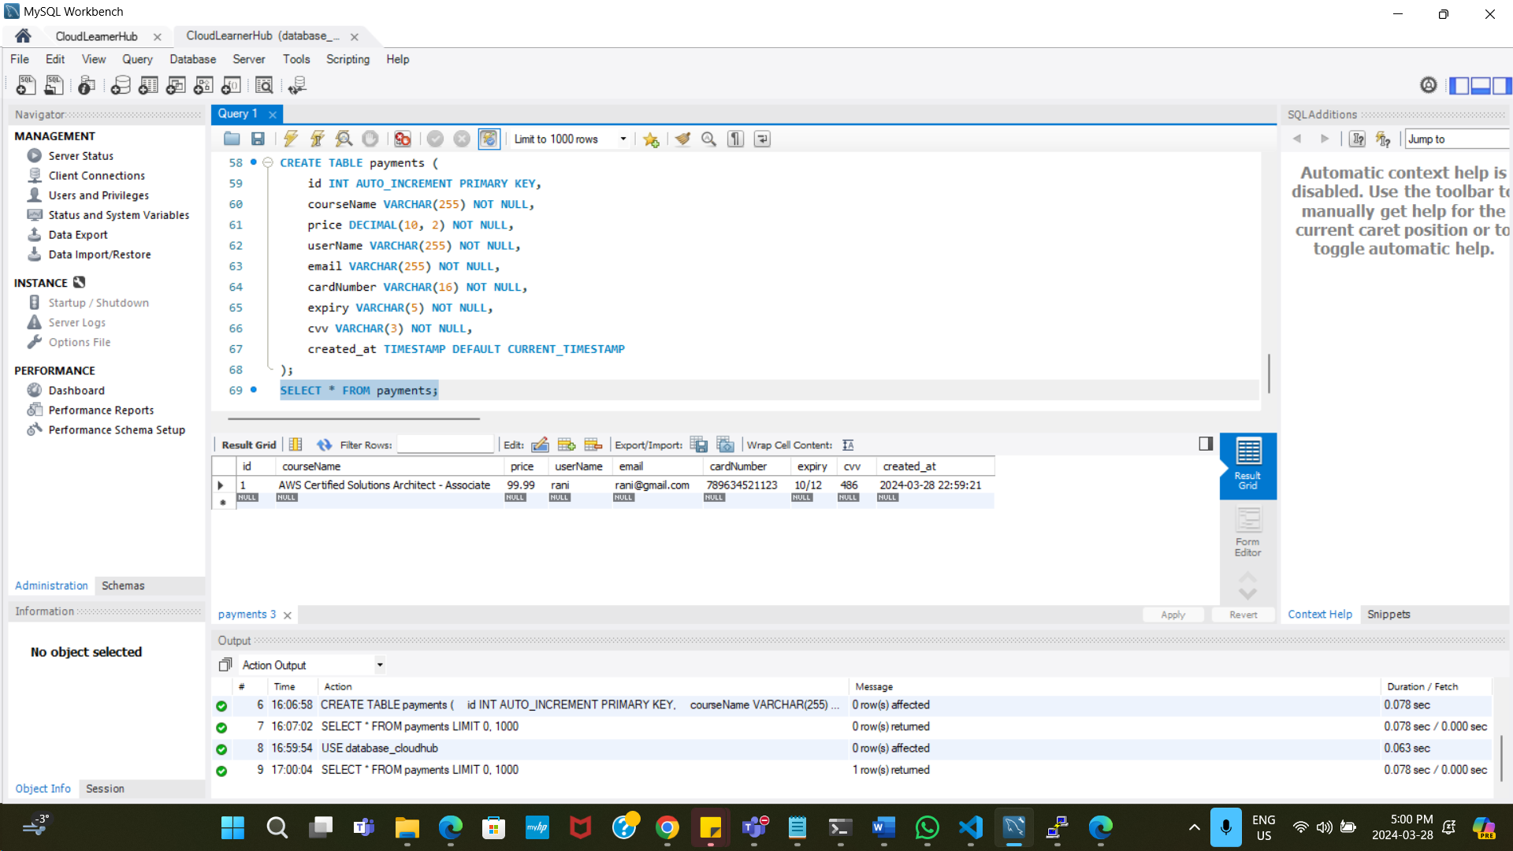

Git: <https://github.com/Akila-19/CloudLearnerHub.git>

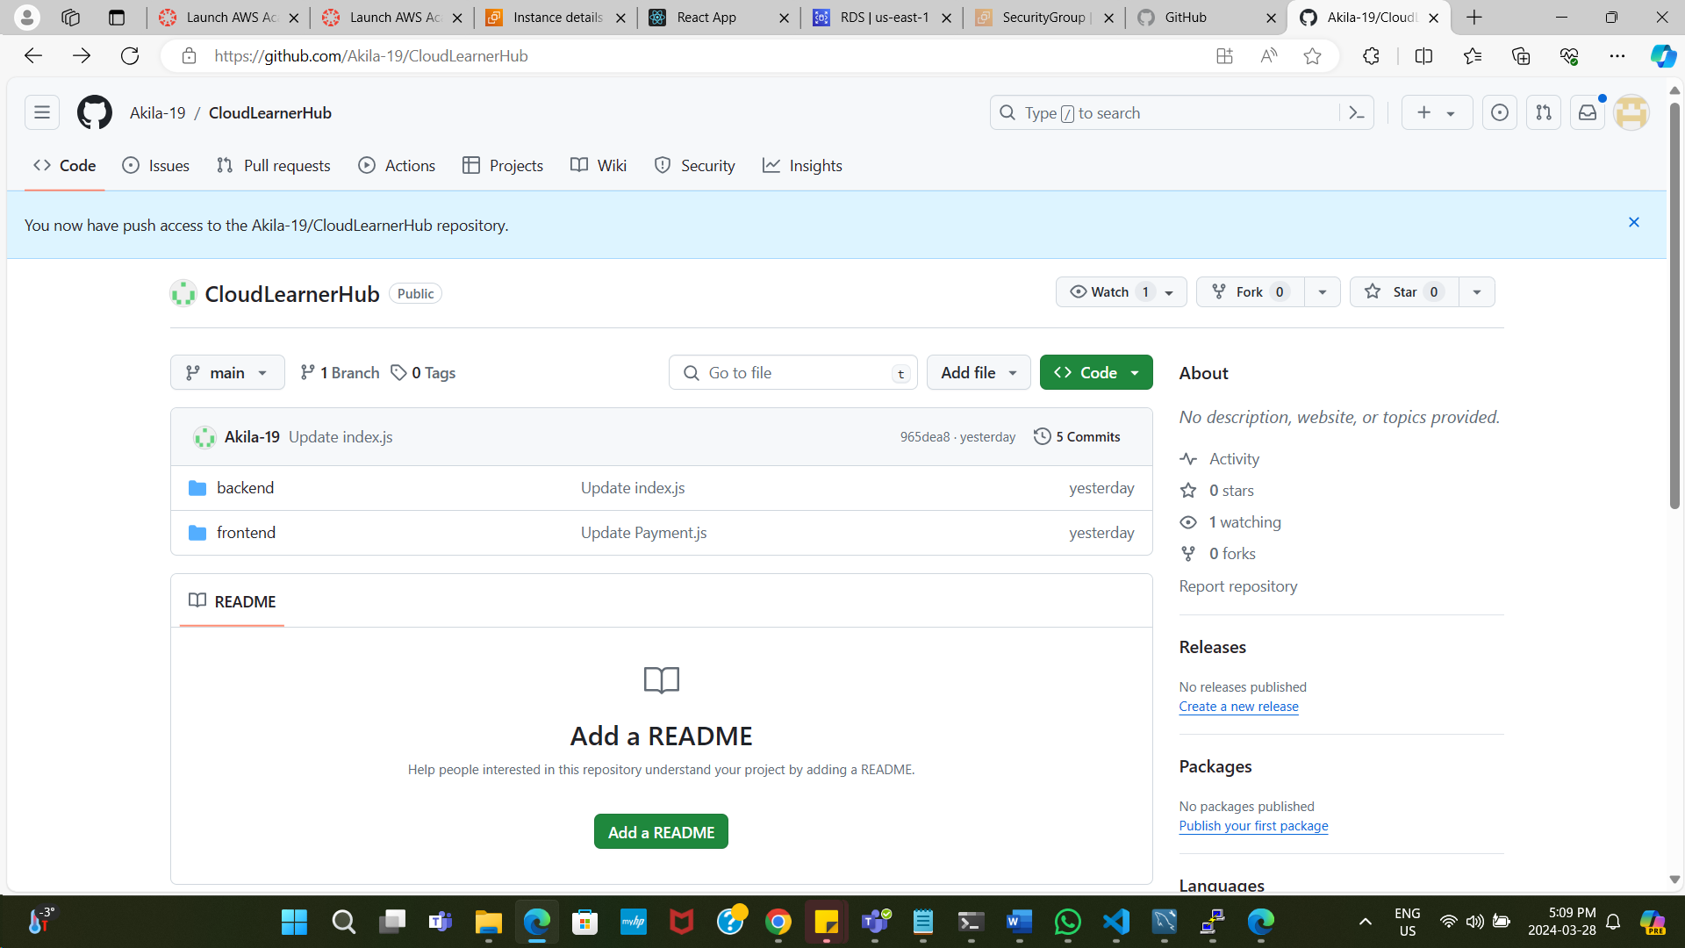

**Reflection:**

We have learnt the importance of thorough planning and collaboration in developing a dynamic website with integrated cloud services. We have gained insights into designing user-friendly interfaces and deploying scalable infrastructure using Terraform and AWS services.